High Jump

AIM: The goal in jumping is to maximise either the measured distance or height that the athletes jump. Several very important commonalities exist among the jumping events and an understanding of them will help a coach working with athletes in this event group. The distance and height are determined mainly by the following three parameters: a) velocity at take-off, b) angle at take-off and c) height of centre of mass at take-off.

The movement of the HIGH JUMP can be broken down into FOUR main phases:
1) Approach, 2) Take-off, 3) Flight, 4) Landing.

1) Approach: Should be fast (but appropriate to athlete’s ability). Accurate/Consistent (i.ie repeatable time after time). A good approach should prepare the athlete for a successful take off.
2) Take off: Ensure that the centre of mass is as high as possible at the moment of take-off. Take off at the optimum angle (leaning away from the bar with take-off foot pointing toward back corner of mat). Take-off foot should be a fast ‘pawing’ action. Knee of the free leg is driven upwards along with the arms. Hip, knee and ankle joints are fully extended.
3) Flight: To minimise the travel distance of the athlete through the air. The high point should be directly over the top of the bar to ensure the athlete clears successfully.
4) Landing: The goal is to always land safely on the correct surface/mats to avoid injury.

Points to REMEMBER:
- Increase stride frequency at the end of the approach.
- Active foot plant with the entire sole of foot at take-off.
- Forceful lead/free leg.
- Full extension of hip, knee, ankle.

Points to AVOID:
- A decrease in speed during approach.
- Lowering of the centre of mass.
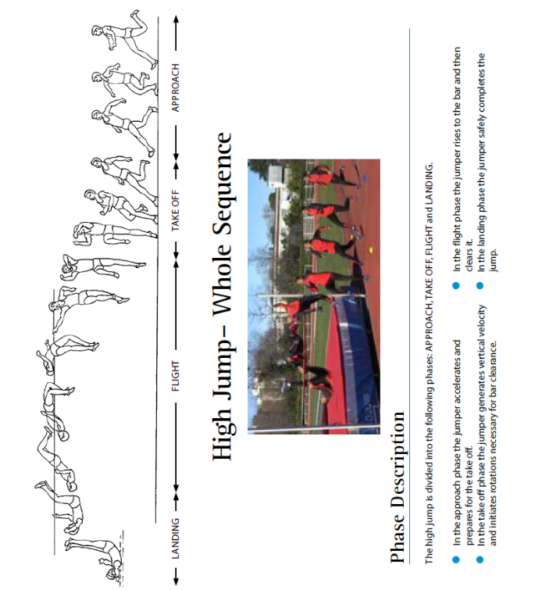
NOTE: High mechanical load of high
Jumping exercises on entire body (especially the
ankle and knee joint can lead to injury if
overloaded).

Teaching Progression High Jump
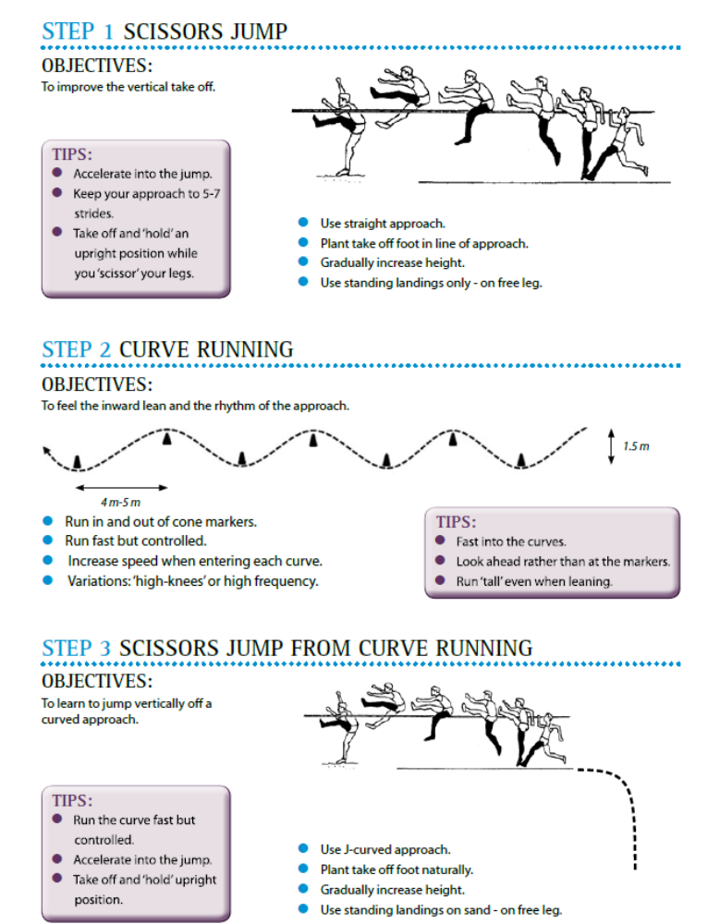

Scissors Jump

An athletes first high jumping experience should involve using the scissors technique. It is safer, and more suitable for inexperienced youngsters. It should not be seen as an outdated technique but viewed as a vital part of the teaching process. Skipping this important progression may endanger the athlete with never reaching their full high jumping potential. Even with experienced athletes it should remain part of their jumping sessions from time to time.

Run and leap onto the mats – no high jump bar

Aim:
- To give the athletes confidence in leaping up onto the mat.
- To develop a basic scissors take-off.
- To determine the preferred take-off leg.
- To develop a feet-first landing position.

Activity:
- The athletes run in a controlled manner directly at the mats and, taking off from one foot, leap up onto the mat to land on the other foot. The athlete’s forward momentum may see them take several steps forward on the mats after landing.
- Ensure that the athlete takes off from one foot and lands on the other foot before the take-off foot is also brought down for balance.
- Ensure an upright (i.e. on feet) landing position on the mats.
- Make sure that athletes don’t slow down or stop before taking off. It is a continuous, flowing action.
- Instruct the athletes to come to a stop on top of the mats and, if using the higher style mats, carefully climb down afterwards.
- It may help to tell athletes that the action is a “step” up onto the mats. Asking the athletes to “spring” or “pop” up onto the mats can also be useful.

NOTE:
With a large group, it is worthwhile to organize this activity so that two to three athletes are active at once, which cuts the waiting time. Depending on the size of your landing area, split the group into two or three lines side-by-side, and several metres apart, facing the mats. This will allow more than one athlete to run in and jump at a time. This can be done very safely if you clearly indicate that the athletes MUST land on their area of the mat. This can be further emphasized by dividing the runway with ground markers and the landing area with elastic bars, skipping ropes, etc.
Try to keep the group moving through quickly, but make sure that the mats are clear before you give the signal for the next athletes to have their turn.

Skill Extensions:
- Once you can see that the athletes have confidence in leaping up onto the mats, gradually introduce the following technical points:
- A “tall” take off position. The head should be up, eyes looking forward.
- A high lead knee drive on take-off.
- A quick last-two steps on take-off. (Very young athletes can grasp this concept).
- Encourage the athletes to try to “float” or “freeze” in the air after take-off to attain more height and time in the air.
- Ask the athletes to note which is their preferred take-off foot.

Scissors onto mats – no bar

Aim: To introduce the basic scissors high jump action from an angled approach.

Set Up: The athletes start from either the left or right-hand side of the mats depending on their preferred take-off leg (left-hand side for right foot take-off; right-hand side for left foot take-off) and line up behind a ground marker approximately 8-10 metres back from the mats and at a 35-degree angle to the front of the mat.

Activity:
- One at a time the athletes run in towards the mats and attempt to scissor jump onto the mats, landing in an upright, standing position.
- Tell the athletes that they are performing the same skill as before, the only difference is the angled approach to the mats.
- Ensure that the athletes use the correct take-off foot according to the side that they are running in from. The leg closest to the mats drives up first. Allow the athletes to change sides if necessary.
- Watch for athletes who run straight at the mats (as in the first activity). It can help to ask the athletes to aim for the far back corner of the mat when running in and taking off to ensure that their inside shoulder is alongside the mat at take-off.
- Encourage an accelerating run up to the mats. Watch for athletes who use a one-paced run up.
- Continue to encourage a quick last two steps.
- Encourage a driving up of the knee on take-off, rather than driving the foot up with a straight leg.
- Emphasize landing in a standing position.
- Talk to the athletes about landing safely in the centre of the mats. Indicate, or mark, a preferred take off area that will ensure that the participants will land safely on the mats. Encourage the athletes to abort attempts that do not bring them into this take off area.

SCISSORS ONTO MATS – WITH BAR

Aim: As above but with introduction of physical bar for athletes to clear.

NOTE: Please use elastic or ‘bungee’ bar where possible when working with younger athletes. Older athletes can also use bungee bar in training.

HJ – Running the Curve

The approach run is the key to high jump. The approach sets up an athlete’s flight path and, if performed properly, allows the jumper to rotate correctly in the air when using the “flop” technique.

A “flop” high jump approach follows a basic J-shaped curve where the first few steps (3-6 steps) of the run-up are performed in a straight line and the last few (4-5 steps) are performed on a smooth curve. The straight part of the run-up should be used to build up speed, and the curve is used to build up forces that will allow the athlete to rotate correctly over the bar.
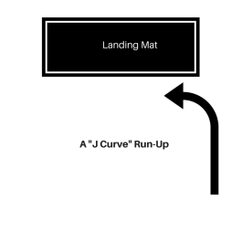
A 7 to 12 stride approach is suitable for most young athletes. During the approach, athletes should have long bouncy strides and active arms. The shoulders need to be held back and the hips high.

- Standing ‘Flop’. Here athletes should be instructed on the final part of the HJ sequence, the landing. Athletes most have a suitable mat to land on and be thought how to land safely and correctly. There are a number of drills to introduce this, see below image.

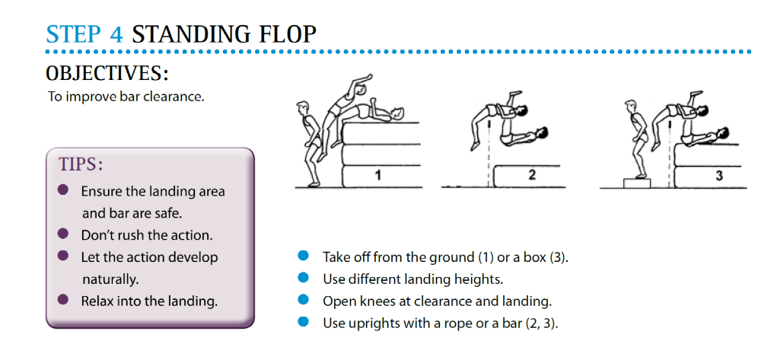

- Start with elementary three stride approach from approx. 45 degrees to the bar. It is important to get athletes jumping from BOTH sides to improve competency and to ensure the more preferred side doesn’t become overdeveloped. This will also reduce risk of injury.
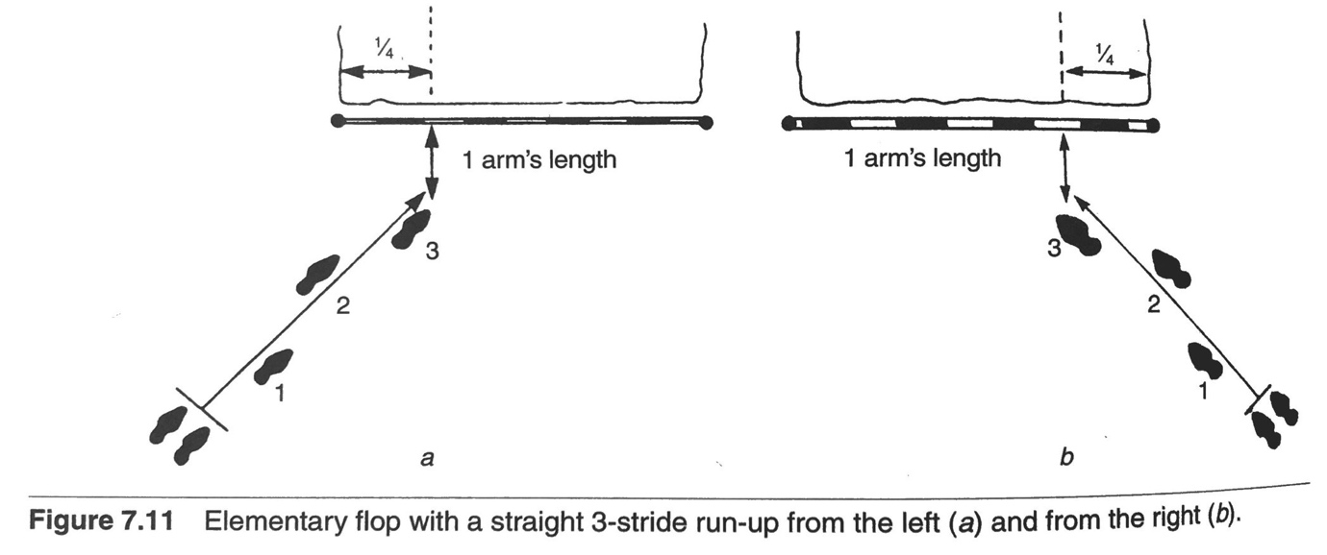

- Introduce athletes to the concept of running in a circle. Place cones around a given circular area and instruct athletes to LEAN into the centre of the circle while maintaining an upright body position. This is an extremely important factor in high jumping and something development coaches overlook at times. Running in a circular motion will also help build ankle strength. Athletes should run in clockwise as well as anticlockwise directions to ensure development occurs evenly on both sides of the body.

See image below on how the LEAN should look.

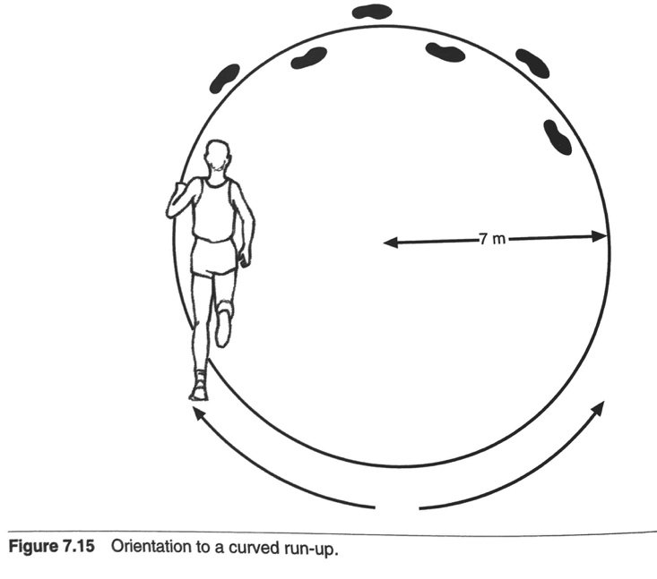
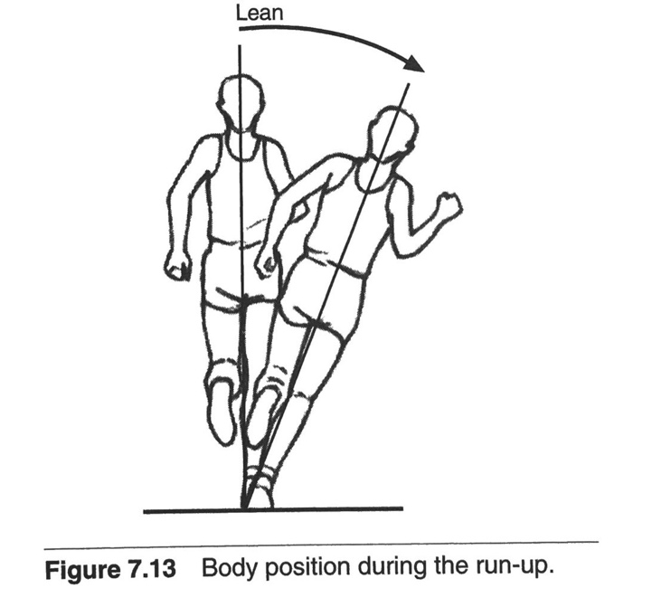

- Figure of 8 running/curve sprinting.

Athletes run in a figure of 8 motion (as previously mentioned, this should be done in both directions for older and younger athletes alike). This again teaches running and leaning on a curve. Games and races can be developed from this to make it fun and interesting for athletes. Use of arms should also be exaggerated.

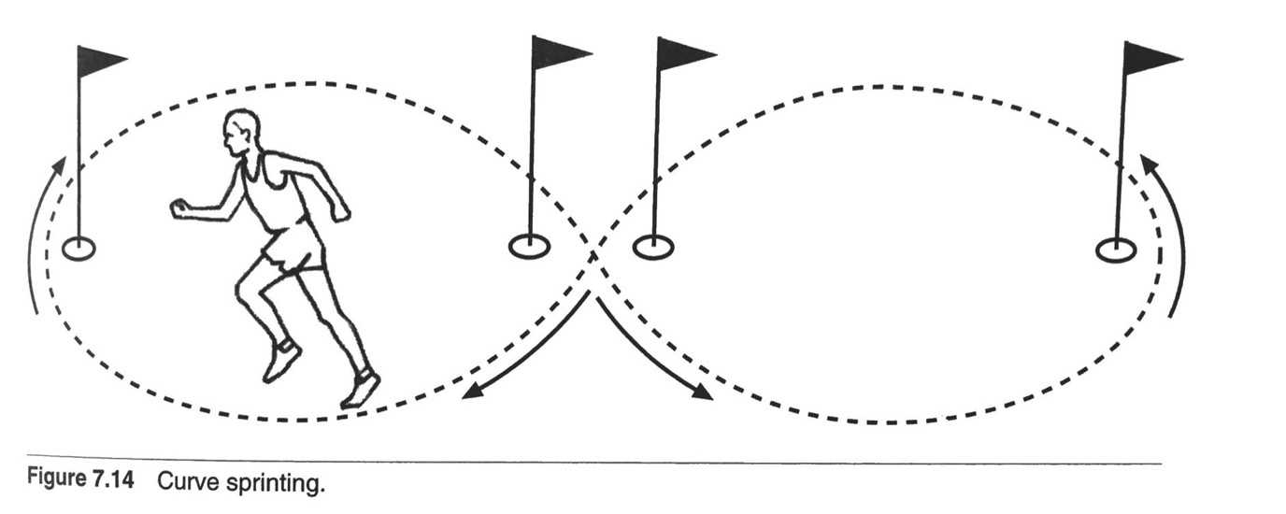

- Finally, all the pieces of the jigsaw can be implemented to get the athletes to ‘FLOP’ successfully and safely. This can be started from 3 strides, then 5 strides, working up to 7,8 or 9 strides, whichever is most suitable for the athlete depending on training age, actual age, experience and competence. It is important to point out again that an athlete should not advance to the next stage of any technical event until they have mastered the basics. TECHNIQUE, TECHNIQUE, TECHNIQUE!
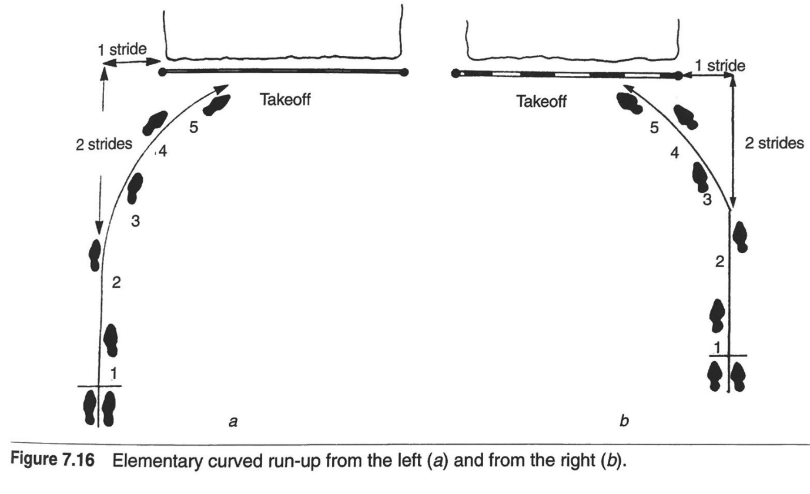

HJ Jumps Circuit:

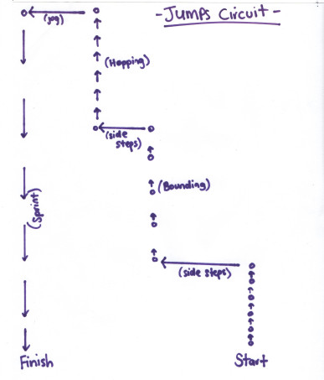
Description
1. From the start point, perform double foot ankle bounces forwards over each cone. Work on pushing off the feet and getting full extension at the ankle. Think about being “bouncy”.
2. Side-step to the next cone.
3. Bound, trying to land next to each cone. Work on even bounds.
4. Turn to face the opposite direction (i.e. face the start) and side step to the next cone. Facing the opposite direction means that the athletes work both sides of the body during the circuit.
5. Hop, trying to get a good cycle with their hopping leg. Use large even hops.
6. Jog to the next cone.
7. Sprint to the finish.

MIX it up, be creative!

Coaches could give athletes a small break between repetitions if you were concentrating on quality of technique more than endurance.

Useful Links:
High Jump:
https://coachingyoungathletes.com/category/articles/high-jump/

References:
Website: https://coachingyoungathletes.com/

Book: IAAF Run! Jump! Throw! – The Official IAAF Guide to Teaching Athletics

Book: Conditioning Young Athletes – Michael Carrera and Tudor Bompa (2015).

Book: Fundamentals of Track and Field 2nd Edition – Gerry Carr.

